Year 12 3CD Mathematics Specialist Term 2, 2010


Test 4
(Matrices, Exponentials and Logarithms, Functions)

This assessment contributes 5% towards the final year mark.
45 minutes are allocated for this task.

MARKING KEY and SOLUTIONS

Part A The use of a CAS calculator is assumed.
(12 minutes permitted)

Do NOT turn over this page until you are instructed to do so.

1. A native reptile of MathMagic Isle called the hypottentot has a generation change every 2 years. The table below shows the survival rates, breeding rates and the initial population profile for 5 of the age groups :

Age (years) | 0-2 | 2-4 | 4-6 | 6-8 | 8-10
Survival Rate | 0.6 | 0.8 | 0.7 | 0.4 | 0
Breeding Rate | 0.1 | 0.9 | 1.4 | 0.5 | 0.4
Initial Population | 10 | 12 | 15 | 20 | 10

a. State the Leslie matrix L for this colony of hypottentots.

L = 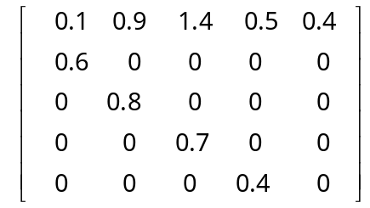
✓ 5 x 5 matrix with breeding rates in Row 1
✓ Other elements correct

[2]

b. Use matrix L to determine the population profile after 10 years.
✓ 5 generations or transitions
10 years is equivalent to 5 generations.
✓ expression for P(5)
P(5) = L⁵ x P(0)

P(5) =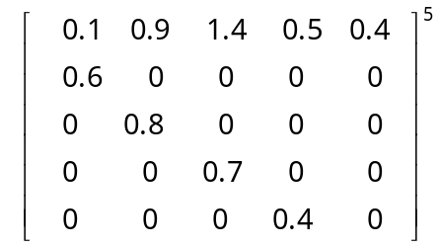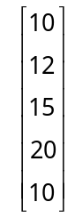 = 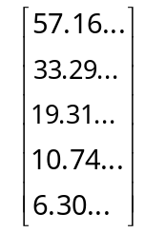
✓ sensible conclusion using whole values

So after 10 years there will be approximately 57 aged 0-2 yrs, 33 aged 2-4 yrs, 19 aged 4-6 yrs, 11 aged 6-8 yrs and 6 aged 8-10 yrs.

[3]

c. Determine the long term inter-generational growth rate, as a percentage.
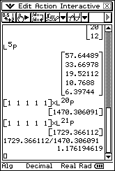

From CAS calculator, inter-generational growth rate is approx 17.6%.
✓ percentage growth conclusion

[3]
✓ explores consecutive generations for a LARGE number of transitions.
✓ determines totals for each generation.

2. The graph of function f(x) = 0.5(x + 2)(x – 3) is shown below.

Region A is bounded by the curve, the x axis, and the lines x = 0 and x = 3.
Region B is bounded by the curve, the x axis, and the lines x = 3 and x = a.
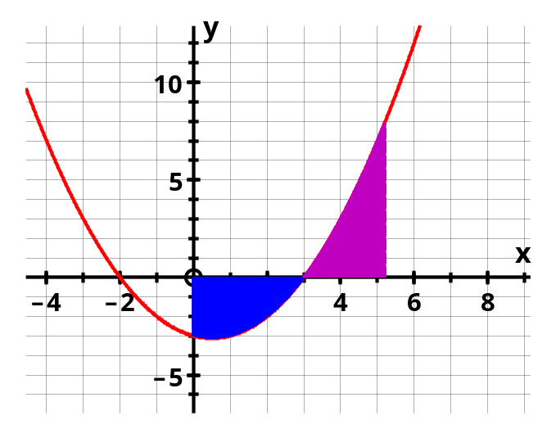

If the areas of regions A and B have the same area, determine the value of the constant a correct to 0.001.

Area A = - 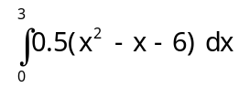 = 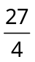
Area B = 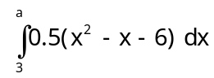

Hence solve =

From CAS calculator : a = 5.058 (3 d.p.)

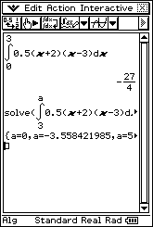
✓ value for Region A
✓ expression for Region B
✓ equation for equal areas
✓ solves for a correct to 3 dp

[4]

Year 12 3CD Mathematics Specialist Term 2, 2010

Test 4
(Matrices, Exponentials and Logarithms, Functions)

This assessment contributes 5% towards the final year mark.
45 minutes are allocated for this task.

Part B No calculator to be used.
(33 minutes permitted)

MARKING KEY and SOLUTIONS

Do NOT turn over this page until you are instructed to do so.

3. Consider the following transformation matrices in the co-ordinate plane :

R rotates 180º about the origin
D dilates vertically about y = 0 with factor 1.5
S downward shear parallel to the vertical axis with factor 1

a. Give matrices R, D and S.

R =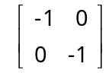 D =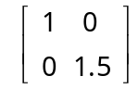 S = 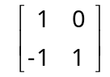
✓ each matrix correct

[3]

The 3 diagrams below show a parallelogram.

Draw the image of this parallelogram under the action of transformation :

b. D (on Diagram 1)
[1]
c. S (on Diagram 2)
[2]
d. R then S (on Diagram 3)
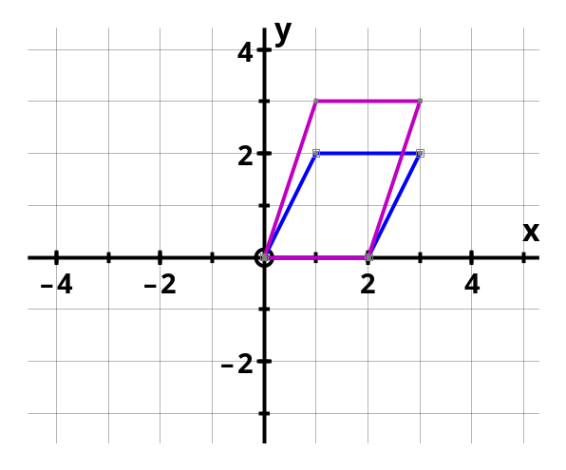
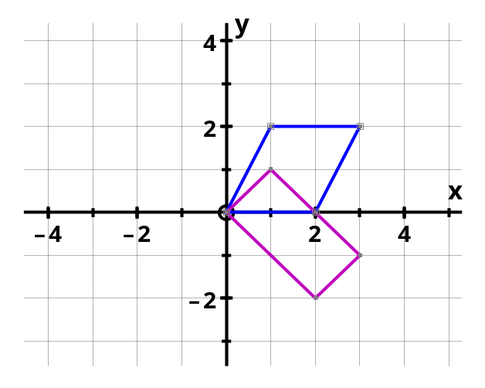
[2]

Diagram 1 Diagram 2
✓ shows the dilation correctly
✓ shows image of (3,2) as (3,-1)
✓ shows the TOTAL image correctly as a rectangle
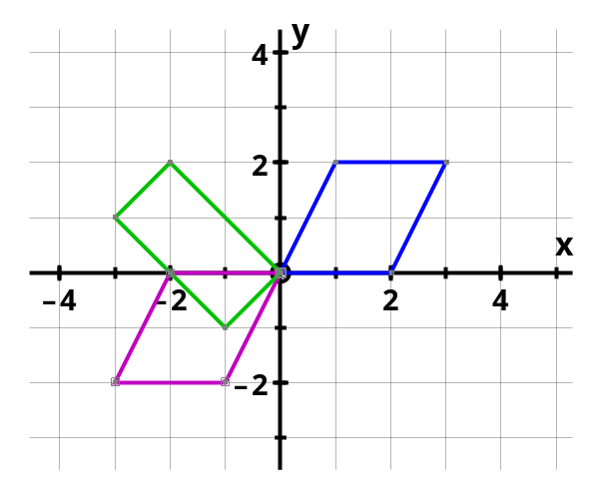

✓ shows the rotation correctly
✓ shows the shear correctly
Diagram 3

3. e. Does transformation matrix S change the area of any object it transforms ?
Explain.

S = det(S) = 1(1) - (-1)(0) = 1

Hence since |det(S)| = 1, then the AREA of the image will NOT be any different from the area of the object.

✓ calculates the determinant
✓ makes the correct conclusion

[2]

f. If the parallelogram is transformed by matrix D then S, what matrix will return the resultant image back to the original parallelogram ?

Transformation T : D then S i.e. T = SD
We require T⁻¹.

T = SD = = 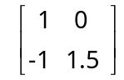

T⁻¹ = 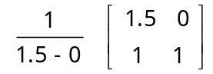 = 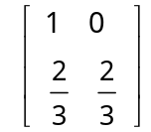

✓ interprets matrix SD
✓ calculates matrix SD
✓ calculates the INVERSE to return image to the original

[3]

See next page
4. Find the following indefinite integrals, using an appropriate Calculus technique :
[ONE mark will be given for a correct answer only]

a. 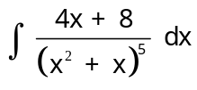 = 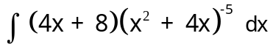
= 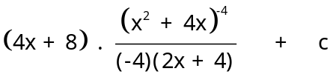
= 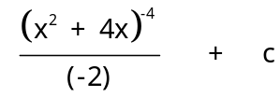
✓ integrates power (-5)
✓ derivative factor cancels
✓ simplifies expression
= 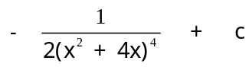

[3]

b. 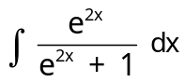 = 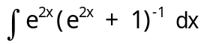
✓ recognises reciprocal function
✓ ln anti-derivative
= 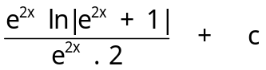
= 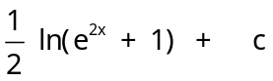
✓ divide by derivative factor to simplify correctly

[3]

c. 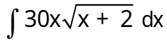 Put u = x + 2 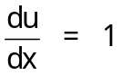

= 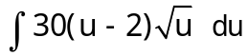
✓ express x in terms of u
= 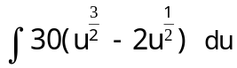
✓ multiply integrand
= 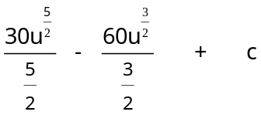
✓ anti-derivative

= 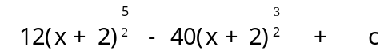
✓ express in terms of x

= 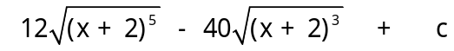

✓ ONE mark penalty in Question 4 for lack of an integration constant

[4]
5. Evaluate the following definite integrals, using the given substitution and an anti- derivative technique : [ONE mark will be given for a correct answer only]

a. 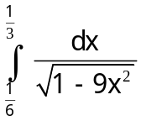 Put 3x = cos θ
x
θ | 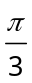
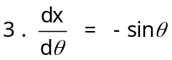
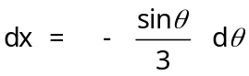

= 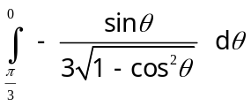

= 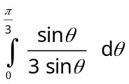 since for 0 < θ < 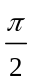, sin θ > 0

= 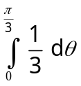

= 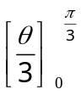

= 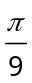

✓ express dx in terms of dθ
✓ change limits of integration
✓ simplifies integrand using the identity for 1 – cos²θ
✓ evaluates correctly

[4]

5. b. Given that 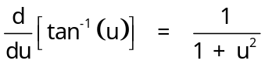 evaluate 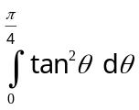 by using u = tan θ.

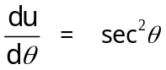 ∴ 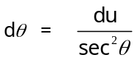
θ | 0 | 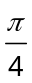
u | 0 | 1
= 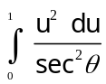

= 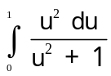

= 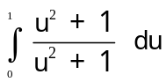 - 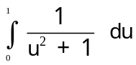
= 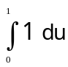 -

= 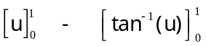

= 1 - tan⁻¹(1) + tan⁻¹(0)

= 1 -

✓ expresses dθ in terms of du
✓ change limits of integration
✓ uses indentity for sec²θ = 1 + tan²θ
✓ splits integrand into 2 parts
✓ anti-derivatives correct (using the given result for inverse tangent)
✓ evaluates correctly

[6]

End of Assessment Task

